**Release Plans**

**Team Number 111**

|  |  |
| --- | --- |
| Student Number | Team Member Name |
| n9458816 | Alexandria Griffiths |
| n9588868 | Akash Mehta |
| n9378171 | Ronald Leung |
| n8599751 | Lorenz Esparcia |
| n9437681 | Alexander Stevens |

Tutor: Prakash Bhandari

Version: 1.2

Date: 26/10/2016

**Table of Contents**

Release Plan

Release 1

Access to Application

Back-end Development

Tablet Compatibility

User-Specific Access

Release 2

Link Back-end to Front-end

Notification System

Payment System

Delivery Schedule

Release Plan Notes

Estimated Velocity

Release Plan Update 21/09/2016

Release Plan Update 08/10/2016

Release Plan Update 24/10/2016

Release Plan Update 26/10/2016

Summary

Future Recommendations

Burndown Charts

Figure 1: Sprint 1 Burndown Chart (Story Points vs. Date) 10

Figure 2: Sprint 2 Burndown Chart (Story Points vs. Date) 11

Figure 3: Sprint 3 Burndown Chart (Story Points vs. Date) 12

Figure 4: Sprint 4 Burndown Chart (Story Points vs. Date) 13

Figure 5: Release 1 & 2 Burndown Chart (Story Points vs. Sprint) 14

**Release Plan**

**Release 1**

Delivery date: 21/09/16 [week 9]

Total Story Points: 105

The goals for this release include templates for form submission, a front-end website application for users, creating the back-end SQL database(s) for the front-end application, writing queries to organise the accumulated data, portable (tablet) access to the implementation and user-specific access to data.

**Access to Application**

Involves creating the front-end website application and the template for form submission. Creating a permit form template allows the user to easily submit necessary information that remains consistent and usable within the proposed database. A front-end website application ensures the user has access to the form and the ability to complete it immediately with the intention to be capable of conveniently using a multitude of available devices.

|  |  |  |
| --- | --- | --- |
| **Story ID** | **Story Title** | **Story Points** |
| **1** | Access - Permit Form | 16 |
| **2** | Access - Online | 16 |
|  | Story Point Sub-Total: | 32 |

**Back-end Development**

Involves creating the back-end SQL database(s) as well as writing SQL queries to organise data. Creating and eventually linking the back-end SQL database(s) to the front-end application ensures instantaneous recording (from form submissions) and retrieval of data. Configuring data to ensure that each permit entry is uniquely identified is imperative to prevent duplicity and in creating an ordered database for ease of use and reference. Writing SQL queries ensures that department members can organise data to suit their needs in efficiently locating and completing approvals, payments, and issue resolutions.

|  |  |  |
| --- | --- | --- |
| **Story ID** | **Story Title** | **Story Points** |
| **20** | Unique - Permit Entry | 1 |
| **21** | Organise - Approval Status | 2 |
| **24** | Organise - Payment Status | 2 |
| **28** | Organise - Resolution Status | 2 |
|  | Story Point Sub-Total: | 7 |

**Tablet Compatibility**

Involves providing portable access to the application via a tablet-like device. Providing portable access to the web application will ensure that Patrol Officers are able instantaneously log and retrieve data when issuing citations. Mobility is imperative in recording on-the-spot violations. For mobile and tablet users that have data stored on the database, portability is important for their convenience and to ensure their access to records or form submissions via their device. Failure to implement a successful, live mobile iteration would lead to data integrity issues if patrol officers without a live or current connection log the same citation twice, mobility issues if a patrol officer needs to log a violation but is unable to access a way to do so on-site and accessibility issues if users are unable to access the UI to submit forms and access records from their mobile devices and tablets.

|  |  |  |
| --- | --- | --- |
| **Story ID** | **Story Title** | **Story Points** |
| **15** | Access - Portable | 2 |
| **17** | Access - Physical Print-out of violation | 4 |
|  | Story Point Sub-Total: | 6 |

**User-specific Access**

Involves granting or restricting access to specific pages according to user role. For security reasons and in the best interest of user confidentiality, restrictions and granted permissions are a necessity for the online database. Department members with the correct authority need access to the data to approve or edit documents whereas other staff and students must be restricted to only their personal records or open forms.

|  |  |  |
| --- | --- | --- |
| **Story ID** | **Story Title** | **Story Points** |
| **9** | Exclusive Staff/Student Permit | 16 |
| **10** | Access - Issue Report Forms | 16 |
| **12** | Access - Citation Forms | 16 |
| **13** | Templates w/ Compulsory Fields | 4 |
| **14** | Up-to-date Connection | 8 |
|  | Story Point Sub-Total: | 60 |

**Release 2**

Delivery date: 26/10/16 [week 13]

Total Story Points: 44

The goals for this release is to link and integrate the developed applications and databases to finalise the development of the Health and Safety Department’s computing solution initiative. This release observes the functionality of the final result.

**Link Back-end to Front-end**

Involves linking the back-end database to the front-end application so that its data can be accessed via the website application. Accessibility to the website application is imperative for all levels of users. College Personnel require the ability to access and submit permit requests, violation forms and H&S incidents to the department, Patrol Officers require access to log violations and department members are required to constantly update and check the details of existing entries. A constant connection is necessary to ensure continual, up-to-date access to the database from the user interface and to prevent duplicitous data.

|  |  |  |
| --- | --- | --- |
| **Story ID** | **Story Title** | **Story Points** |
| **5** | Access - Permit Validity | 4 |
| **27** | Regular Edits to H&S Issues | 4 |
| **29** | Upon Resolution, Enter Additional Info | 8 |
|  | Story Point Sub-Total: | 16 |

**Notification systems**

Involves sending automated notifications and confirmations via the registered preferred method of correspondence to notify recipient of changes in circumstance (new violation, new permit request, overdue payment etc.). An automated notification and confirmation design will ensure that communication is effective and succinct for all processes. Informing users during different stages of application aspects will prevent confusion and ensure a greater overall clarity that is imperative to a higher quality user experience. Being notified with a confirmation of completed tasks will also serve to increase overall efficiency as users will not be required to constantly check back at the status of tasks, resulting in a greater fluidity between processes.

|  |  |  |
| --- | --- | --- |
| **Story ID** | **Story Title** | **Story Points** |
| **3** | Notification - Permit Approval | 2 |
| **4** | Access - Physical Approved Permit | 1 |
| **6** | Notification - new Violation | 2 |
| **16** | Notification - Digital to violator | 2 |
| **18** | Notification - new Permit Request | 2 |
| **25** | Automated - Overdue Notification | 2 |
| **26** | Notification - new H&S Issue | 4 |
| **23** | Ensure Physical Permit for Vehicle Owner | 1 |
|  | Story Point Sub-Total: | 16 |

**Payment system**

Involves creating a secure payment system for violation fines with a range of online payment options available. A flexible, multi-optional payment system is vital in ensuring that payments are suited to the users and as such can be completed promptly. Information is obtained from the database to provide a detailed explanation of the cost of the violation. This will prevent confusion for users and lower potential rebuttals in some cases. Security is necessary in providing a safe experience and ensuring confidentiality among users.

|  |  |  |
| --- | --- | --- |
| **Story ID** | **Story Title** | **Story Points** |
| **7** | Access - varied Payment Options | 8 |
| **8** | Detailed Payment System | 4 |
|  | Story Point Sub-Total: | 12 |

**Delivery Schedule**

|  |  |  |  |  |  |  |  |
| --- | --- | --- | --- | --- | --- | --- | --- |
| Week 6 | Week 7 | Week 8 | Week 9 | Week 10 | Week 11 | Week 12 | Week 13 |
| Sprint 1 | | Sprint 2 | | Sprint 3 | | Sprint 4 | |
| Release 1 | | | | Release 2 | | | |

**Release Plan Notes**

* Stories #11, #19 and #22 are not included in the plan, as the priorities for these User Stories were set to ‘Won’t’.

**Estimated Velocity:** 37.5 **Stories Points per Sprint**

**Release Plan Update 21/09/2016**

* Release 1 delivery date was corrected from ~~27/09/2016~~ to 21/09/2016
* Release 2 delivery date was corrected from ~~25/09/2016~~ to 26/09/2016
* Story points of ‘Exclusive Staff/Student Permit’ adjusted from ~~2~~ to 16
* Total points of release 1 adjusted from ~~83~~ to 97
* The progress of the Release Plan can be found in the Burndown Chart PDF provided
* The table on the next page is a table for reference for Release Plan 1’s Progress
* For further information on the progress of sprint 1 and 2, refer to Sprint 1 v1.1 and Sprint 2 v1.1

**Future Recommendations:**

For sprint 3 and 4, the use of story points will be re-evaluated, to correspond with the purpose and functionality of user story points. The future sprint plans for 3 and 4 (release 2) will have adjusted story points that are relative and dependent on the value of story point’s e.g. 1 story point = 0.5 hours. Furthermore, they will be adjusted in a manner that will not trivialise the concept of story point, whilst avoiding the interruption of workflow that Team 111 will be partaking.



**Release Plan Update 08/10/2016**

* Changed Release 2, Story ID 29’s Story Title from ‘~~Dept Member (H&S)’~~ to ‘Upon Resolution, Enter Additional Info’

**Release Plan Update 24/10/2016**

* Estimated Velocity adjusted so that Velocity of Release/Sprint Plan functions as intended.
* Story #14 ‘Up-to-date Connection’ was added to the documentation of Sprint 2, as the story was completed in Sprint 2 when databases went live, despite being initially documented in Sprint 3.
* Release plan notes added, detailing User Stories with ‘Won’t’ Priorities.
* Release 1 and Release 2 adjusted to Story #14 change.
* Burndown Charts of Sprint and Release plans added
* The table below is a table for the Release Plan’s Progress



**Release Plan Update 26/10/2016**

* Page numbers added
* Header and footer added
* Release Plan Summary and Future Recommendations added

**Release 2 Summary:**

As previously noted in the burndown chart analysis, Release 2 accounts for an estimated 35-40% of the Scrum. However, Release 2 is an important as it is expected that the product be at a satisfactory level that delivers business value to the client. To achieve this, the Sprint 3 and 4 plan was to be developed by the IS students on the premise of finalising the product for Team 113 by the end of the release.

The Sprints stories and tasks included linking the developed front-end and back-end, as well as developing the final required systems; such as payment and notifications for users. These user stories and tasks were completed on time to be demonstrated to the client and missed no requirement as agreed upon by both client and development team. With this release and sprint plan scrum implementation, Team 111 were able to keep track on the development. The stories and tasks that correspond with these plans were then completed in a timely effective manner, where the outcome of Release 2 was successful thanks to the hard work and dedication from the CS students (Alex G and Alex S).

**Future Recommendations:**

Within the Release 2 demonstration, there were a few notes regarding the future developments of the website that could potentially be shown in ‘Sprint 5’:

* Small bug fixes
* Increase of security such as moving rights to create an admin user
* Aesthetics (Refining of style sheets)
* Re-organising of functions for smoother user experience (hiding unnecessary features)

Figure : Sprint 1 Burndown Chart (Story Points vs. Date)

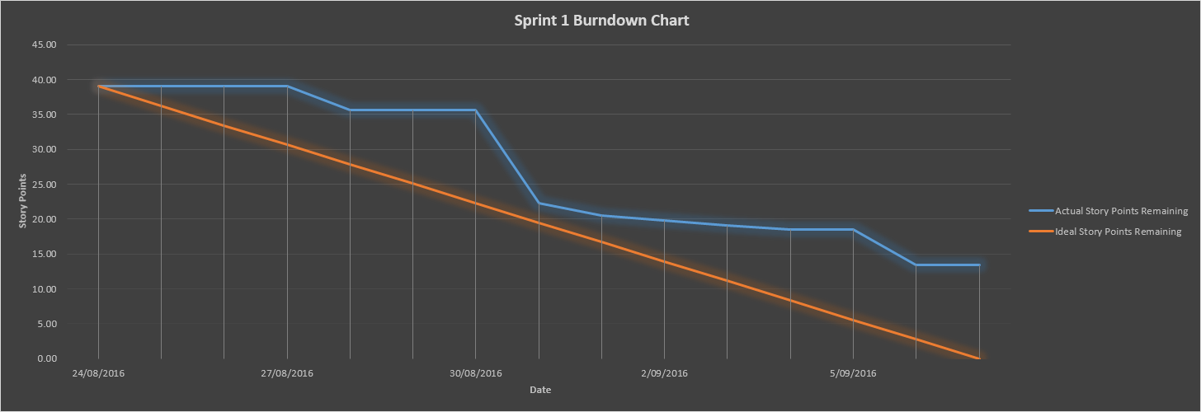

Figure : Sprint 2 Burndown Chart (Story Points vs. Date)

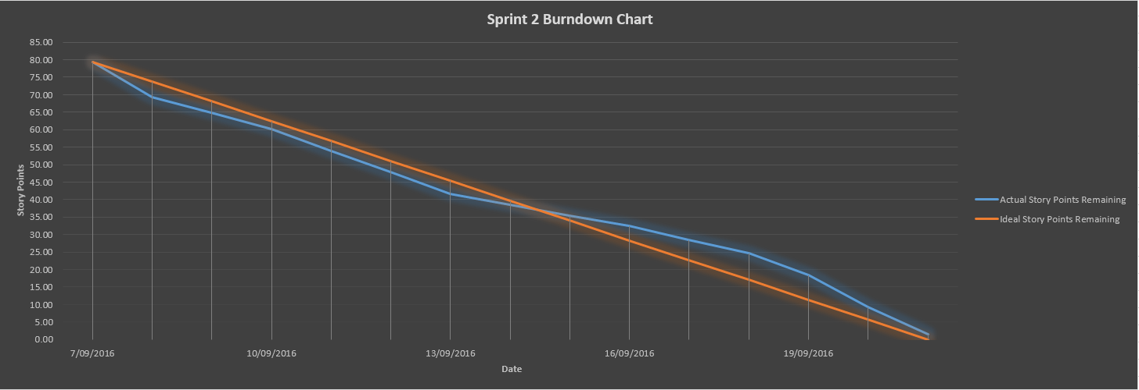

Figure : Sprint 3 Burndown Chart (Story Points vs. Date)

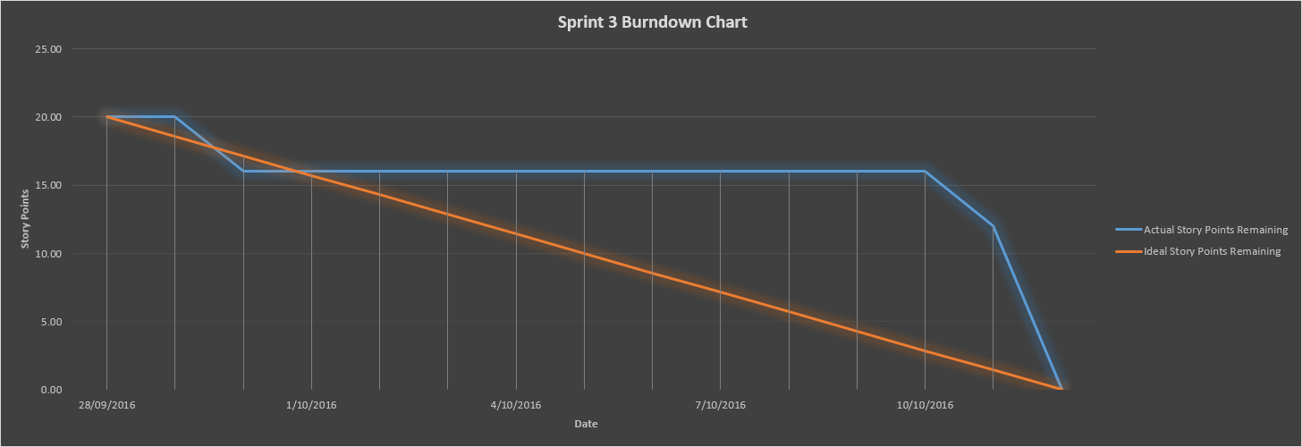

Figure : Sprint 4 Burndown Chart (Story Points vs. Date)

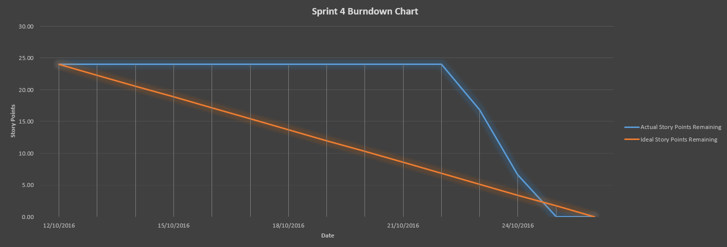

Figure : Release 1 & 2 Burndown Chart (Story Points vs. Sprint)

